PH126 Logic I  Lecture 5
Lecturer: s.butterfill@warwick.ac.uk

⊥, ¬
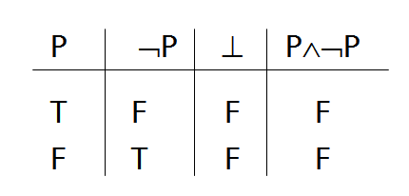

Proof example
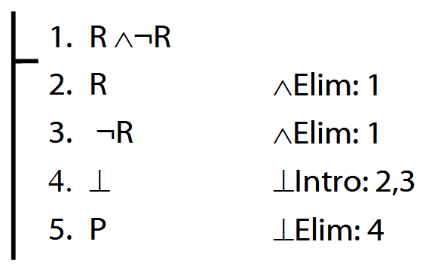
Rules of Proof for →
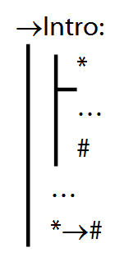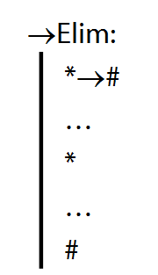

Proof example for →Intro
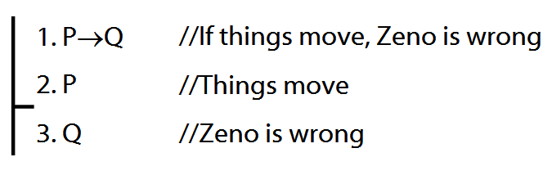

Proof example for →Elim (to complete)
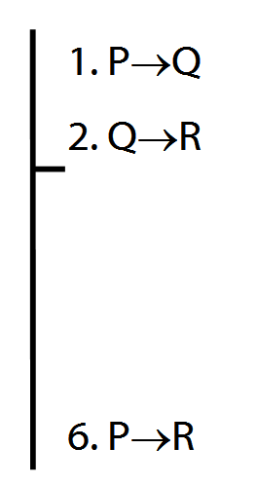

Not all proofs have premises
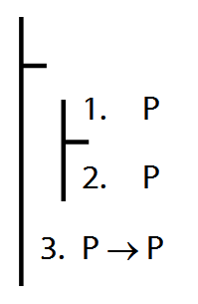

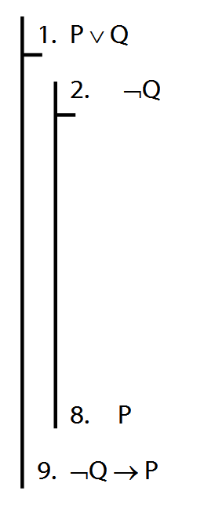
Rules of Proof for ∨
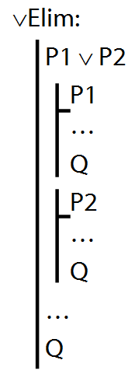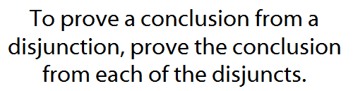

Example proof
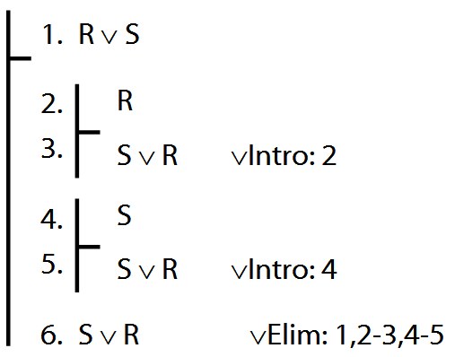

The Syntax of FOL
We define what counts as a sentence of FOL using rules. E.g.:
3. P, Q, R, … are sentences
4. If * is a sentence, then ¬* is a sentence
1. If * and # are sentences, then so is(* ∧ #)
2. If * and # are sentences, then so is (* ∨ #)
So:
a. P is a sentence // rule 3
b. ¬P is a sentence // rule 4, a
c. ( ¬P ∧ Q ) is a sentence // rule 1, b, a
Notes: (1) There is no structural ambiguity in FOL because these rules are formulated to ensure that for any FOL sentence, there is exactly one way of constructing it. (2) We used the notion of a sentence in the rules that define what a sentence is.

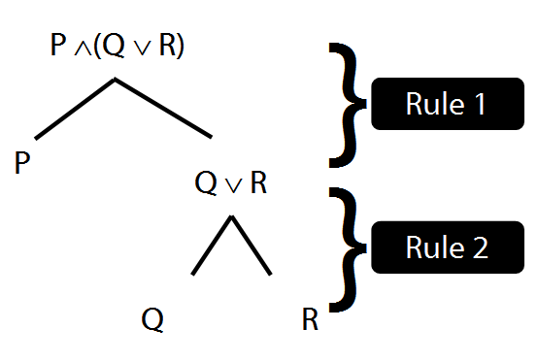
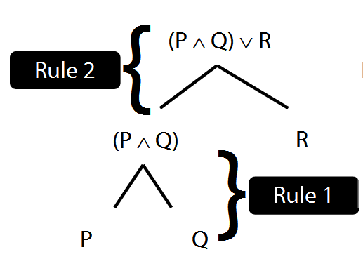

Exercises 02
For your third seminar
Not for fast groups

3.8, 3.12–13 (∨ and ∧)
3.20, 3.21, 3.22 (trans.)
4.4–7 (truth tables)
4.12–4.14 (truth tables)
5.1–4 (validity)
6.1 (proofs)

